Release Held Goods

Audit Parameters  (Advisor receives call from store requesting authorisation to release held order) | Validation | Outcome | Dependency /DATA Requirement
Advisor failed to ask Retail Consultant if the order contains a Gift Card | Advisors need to ask the store assistant if the order contains the gift card.  If advisors failed to ask then it will go as Markdown | Non-Compliant No Poor Outcome | Transcript
Additional security questions not asked for store referral over £500 (non-furniture items only) | If a customer is buying a fashion item more than £500, the advisor has to send out the 4 digit number/pin and confirm the pin back. If this step is not done then Auditor gives Markdown | Non-Compliant No Poor Outcome | Transcript
Reason for referral prompted customer call to discuss account in order to un-set hold marker (e.g. D indicator). Advisor failed to ask Retail Consultant to instruct customer to call - resulting in customer continuing to encounter issues with further orders | - Advisor have to inform the store assistant to request the cx to give us a call before attempting to use their next play card again - Markdown | Non-Compliant Poor Outcome | Transcript
Advisor failed to remind Retail Consultant to get customer to sign till receipt | - After releasing the order, the Advisor has to inform the store attendant to take the signature on the till receipt from the customer. | Compliant with Development | Transcript

Release Held Goods
The customer (credit account) purchases items in the store and proceeds to the till (billing counter).
The store assistant swipes the card to retrieve customer details. If the card and account are in good standing, the transaction is authorized, and the order is released.
If an issue is detected on the account, the system prompts the store assistant to contact the Authorization Center.
The call is routed to the Store Referral Queue, where an advisor connects with the store assistant to determine the reason for the referral.

1. Initial Check: Is this even a Store Card Referral: when the store calls, Advisors need to confirm if the store assistant is actually calling about a store card referral.
If they are great, we move right into the next steps to verify the details.
If it's not a store card referral, then you'll need to direct them to the appropriate department.
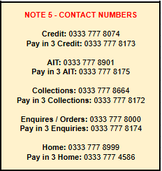

2. Verifying the Referral Details (Security Check)
A- Customer Referral Lookup: Using the customer's number, Store attendants locate Customers referral within the credit review system. If the referral isn't visible, further consultation with Consult X credit on Genesys

B- Customer Details Confirmation: Ask the store assistant to confirm the customer's full name, the exact value of the sale, and the store number. (ID&V)
If everything aligns, the store assistant is good to proceed.
If there's a mismatch, they have to use the decline script.
Markdown- 1- DPA Fail - Non Compliant poor outcome ( If full name is not correct and value of the sale or store number is incorrect and the advisor proceeds with the call then it will go as Markdown.)
2- If sale should have been declined but the advisor accepts the sale then it will go as Non Compliance NO poor outcome
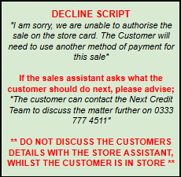

3. Fraud Check:
A- Advisor needs to ask the store assistant “Is the Customer using their virtual card through the Next Pay Card.
Markdown- If the advisor did not ask the question then it will go as non compliance no poor outcome.
B- QR Code Check: If the customer has registered previously, the Advisor needs to guide the store assistant to have the customer log into their new app and bring up the QR Code. Ask the assistant if they can see this QR Code.
If they can, the store assistant is all set for the next step.
If not, we have to use the decline script
Markdown- 1- If the Store assistance confirms it a virtual card and advisor failed to check if its a screenshot then its a markdown —--------------- non-compliance no poor outcome.
2- If sale should have been declined but the advisor accepts the sale then it will go as Non Compliance NO poor outcome

C- Advisor needs to ask the store assistant “ Please ensure that I am not on the Loudspeaker. I am now going to ask you a few security questions without the customer becoming aware of this, so please remain discreet and only answer YES or NO to the following questions.
Is the customer trying to buy a GiftCard using their store card? “
If yes, we need to use the decline script
If No, we will move to next security question
Markdown - if the advisor missed to ask Is the customer trying to buy a GiftCard using their store card then it will go as non compliance no poor outcome.
D- Advisor needs to ask the store assistant “ Is the customer using their store card as payment for Retail Order? “
If yes then we will move to next security question
If No then we will move to Account Checks
Markdown (if not asked the store assistant) - if the advisor missed to ask Is the customer using their store card as payment for Retail Order then it will go as non compliance no poor outcome.
E- Advisor needs to ask the store assistant “ Is there an Electrical item in the order or Branded items over value £100? “
If yes then we will move to next security question
If No then we will move to Account Checks
Markdown (if not asked the store assistant) - if the advisor missed to ask Is there an Electrical item in the order or Branded items over value £100 then it will go as non compliance no poor outcome.
F- Advisor needs to check the Mainframe has the customer received a statement and made a payment on account (excluding 1P -1 Penny authorisation) i.e Established account.
If Yes then we will move to next step
If If not, we have to use the decline script
Markdown - 1- If the advisor missed to check NQRY to check if cx has received a statement and NCCX screen to check the payment on the account then it will go as non compliance no poor outcome.
2- If sale should have been declined but the advisor accepts the sale then it will go as Non Compliance NO poor outcome
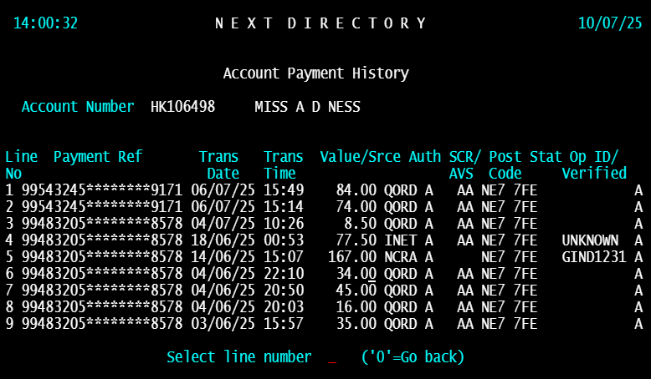



G- Advisor needs to ask the store assistant “ Does the order contain multiple branded items / multiple electronics goods with the order value of £100.
If yes, we need to use the decline script
If No then we will move to Account Checks
Markdown -1- if the advisor missed to ask Does the order contain multiple branded items / multiple electronics goods with the order value of £100 non compliance no poor outcome.
2- If sale should have been declined but the advisor accepts the sale then it will go as Non Compliance NO poor outcome


H - Advisor need to advise the store assistant ‘That is the end of the Yes or No security questions.
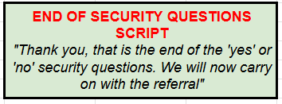
4. Account Check -
A- Advisor needs to check if they can see all of the following: (Out of Scope)
- Have any changes been made made to the account in the last 10 days (e.g Mobile / Email / Address)
- Is the store over 75 miles from the registered account address? (Check via google maps & Nest Store Locator)
- Have they made purchased at 2 or more separate store in the last 7 days? (check via mainframe NSCD)
B- Advisor needs to check on credit iGuide. Is there a hold order indicator set (SCAJ)? If held order indicator set on the account is ‘U’ Transfer to AIT. For all other HOI indicators, follow HOI Check Tab. - (Out Of Scope)

C- Advisor needs to check is the referral reason ‘Account Blocked’ or is there queried reason for the transaction? - (Out Of Scope)

D- Advisor needs to check the FUS stage. Is the account at FUS1 & above? (If already worked due to HOI) - (Out Of Scope)

E- Advisor needs to check is the sale within the customers credit limit? (Out Of Scope)

F- Advisor needs to check is there a credit limit increased pending on the account that will allow the order to be within the limit? (Out Of Scope)

G- Advisor needs to check following the pending credit script. Does the customer accept the credit limit increase? (Out Of Scope)

H- Advisor need to ask is the Order is for Large Home Items (Furniture) Only?
If yes, we need to use the Accept script
If No, we need to do conduct the over £500 check.
Markdown -1- Check if the sale contains non furniture items along with the furniture item. If yes then the value of the on furniture items exceeds 500 £ then advisor needs to follow above 500 £ check if not then its a non compliance no poor outcome.
2- if the advisor missed to ask if the Order is for Large Home Items (Furniture) Only non compliance no poor outcome.
3- If the sale should have been accepted but the advisor declines the sale then it will go as a non compliance poor outcome.
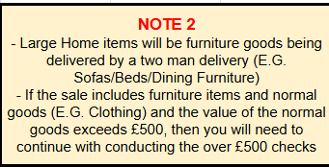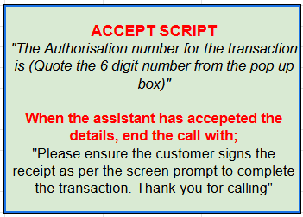

5. Fraud Check -
A- Advisor needs to check mainframe NSCD for the reason for review. Is the referral reason of the following?
- SCA2, SCA3, SCA7, SCA8, SCAC (Out Of Scope- as status can change T+1 day on day of audit)

Or is the value of the sale > £500
If Yes, we need to do conduct the Mobile Number Access Verification:
If No, we need to use the Accept script

Markdown - 1- if the advisor missed to ask if the value of the sale > £500 then its a non compliance no poor outcome.
2- If the sale should have been accepted but the advisor declines the sale then it will go as a non compliance poor outcome.


B- Advisor needs to check if there is a mobile number registered on the account and not changed in the last 10 days?
How to check confirm and screenshot:
Check for the current date and check in mainframe history notes if the customer changed the mobile number in the last 10 days.
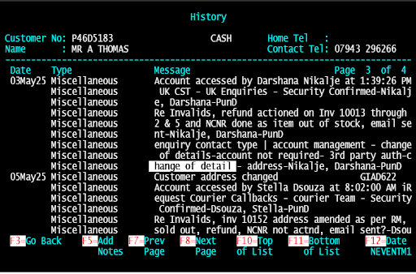
Customer telephone number changes will be shown in this history screen.

If yes, then the advisor needs to ask the store assistant if the customer has access to the number ending in XXXX?
If Yes then we will move to PIN Verification via Mobile
If No then we will move to Email Address Verification

Markdown -
1- Advisor needs to check if phone number has changed in the last 10 days, if yes then advisor needs to use the decline script and if not used the decline script then its a markdown under non compliance no poor outcome.

C- Advisor need to advise the store assistant “ I will be sending the customer a 4 digit pin to their mobile ending in XXXX (Confirm Last 4 Characters), Which the customer will need to confirm back to you.”
Advisor needs to send a 4 digit pin to mobile registered on the account - Can the customer confirm the 4 Digit pin correctly
If Yes, we need to use the Accept script
If No, we need to use the decline script

Markdown - 1- The advisor has to send out the 4 digit number/pin and confirm the pin back. If this step is not done then Auditor gives Markdown as Non-Compliant No Poor Outcome
If Customer gives incorrect Pin and advisor still release the order then again it is a Markdown as Non-Compliant No Poor Outcome
2- If the sale should have been accepted but the advisor declines the sale then it will go as a non compliance poor outcome.


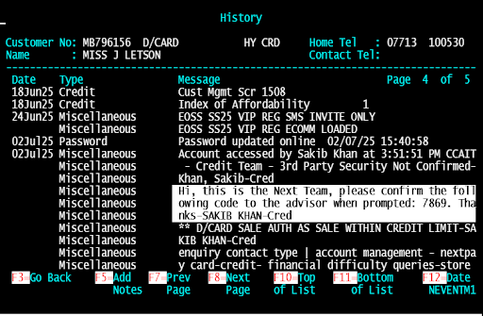
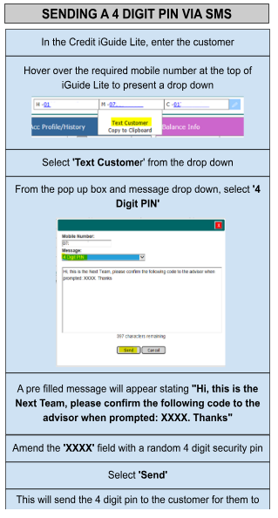

D- Advisor needs to check if there is an Email address registered on the account and not changed in the last 10 days?

How to check confirm and screenshot:
Check for the current date and check in mainframe history notes if the customer changed the Email in the last 10 days.


Customer Email changes will be shown in this history screen.

If yes, then the advisor needs to ask the store assistant if the customer has access to this?
If Yes then we will move to PIN Verification via Email
If No then Decline the transaction and advise the customer to use an alternative payment method or shop online.
Markdown -
1- Advisor needs to check if phone number has changed in the last 10 days, if yes then advisor needs to use the decline script and if not used the decline script then its a markdown under non compliance no poor outcome.
2- If sale should have been declined but the advisor accepts the sale then it will go as Non Compliance NO poor outcome



E- Advisor need to advise the store assistant “I will be sending the customer a 4 digit pin to their Email, Which the customer will need to confirm.”
Advisor on iSolve send the customer a 4-digit pin via email, using the ‘Store Referral - 4 Digit Pin’ macro - Can the customer confirm the 4 digit pin correctly?
If Yes, we need to use the Accept script
If No, we need to use the decline script
Markdown - 1- The advisor must send out the 4-digit number/pin and confirm the pin back. If this step is not done, then Auditor gives Markdown as Non-Compliant No Poor Outcome
If Customer gives incorrect Pin and advisor still release the order then again it is a Markdown as Non-Compliant No Poor Outcome
2- Advisor needs to check the requester tab if the correct email is there for the customer, if advisor fails to do so then it will be Compliant with development

3- If sale should have been declined but the advisor accepts the sale then it will go as Non-Compliance NO poor outcome
If the sale should have been accepted but the advisor declines the sale then it will go as a non-compliance poor outcome.

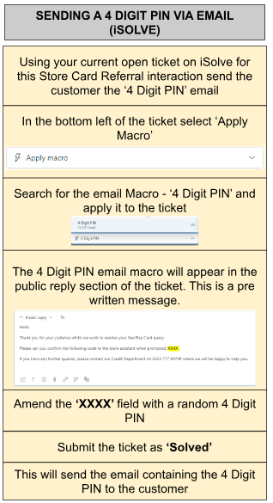
NOTE: If sale should have been declined but the advisor accepts the sale then it will go as Non-Compliance NO poor outcome
If the sale should have been accepted but the advisor declines the sale then it will go as a non-compliance poor outcome.
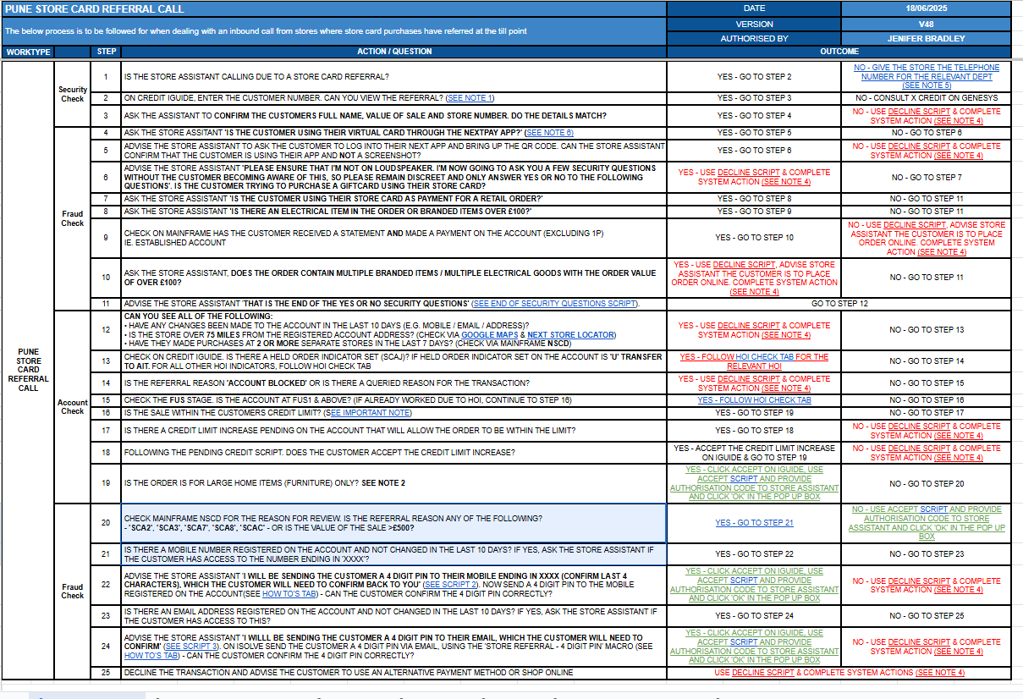
If point 8 is true then point 9 check

